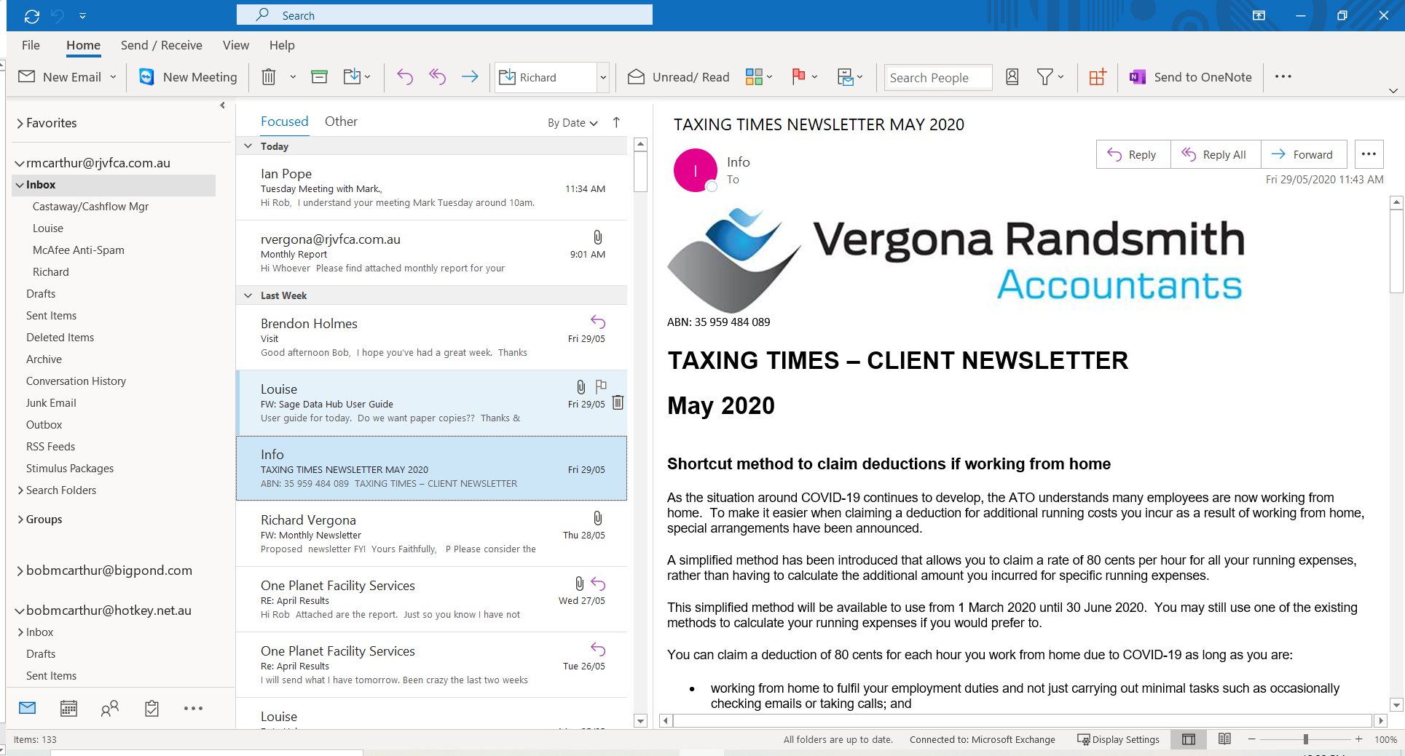

COVID – 19 CONTINGENCY PLAN
STAFF OR RELATED PARTIES CATCH COVID 19
Possible Action | Comments
What will you do if a staff member, their family, or a customer catches Covid- 19?
How will you inform staff and others that may be exposed to the risk of infection?
How will you reduce the risk of others becoming infected, such as closing the premises and cleaning?
How will you monitor the health of others that may be exposed?
How will you continue operating your business, if at all? Can you operate from home or alternative location?
How will you respond to customers not consuming your goods or services for fear of catching the virus?
Can you and your staff work remotely?
Make sure you can work from home and take a laptop they need in case you must close at short notice.
Do you have support systems in place to assist staff working from home (technology support and cybersecurity)?
Update your work from home protocols to factor in security risks.
If staff cannot work remotely and there is no work for them, can they take leave and/or undertake (online) training courses?

Consider developing a special roster so that critical staff are always available to keep essential business systems and processes running.
Have you revisited staff travel plans and their attendance at events?
What arrangements have you put in place to reduce the risk of becoming infected (such as hand sanitizers?
Ensure regular communication with staff, including regular checks on their health and the health of their family.
Update staff records to ensure contact details are correct.
SUPPLY CHAIN DISRUPTIONS
Ask your suppliers whether they expect the crisis impact their ability to supply your needs.
Establish relationships with alternative suppliers and test how quickly they can meet your requirements. Start price negotiations early.
Look for local alternative suppliers, even if more expensive.
If you intend to reduce orders over the crisis, inform your suppliers and check your supply contracts to see what circumstances you can cancel if necessary.
CUSTOMERS
If you have received orders you cannot fill, tell the customer as soon as possible and help them find alternative suppliers
If they are debtors, ask them when they expect to pay you.
Make it known to existing customers that you are open for business.
Provide incentives for existing customers to introduce their family and friends to your business.
Make sure your premises are clean and hygienic for customers. (Hand sanitizers available)
If necessary, update any sales contracts to reduce the risk of customers cancelling sales unnecessarily.

IMPLEMENTING THE PLAN
Consider establishing a COVID-19 response team to assist you manage through the crisis and the recovery.
Test your crisis plan. For example, have all your staff work from home for one day.

